ORDER OF WORSHIP
* Indicates, please stand if able.
First Sunday of Advent December 3, 2023, 9 am
Liturgist: Tom Epps

WELCOME, PASSING THE PEACE OF CHRIST, & ANNOUNCEMENTS
*CALL TO WORSHIP (Isaiah 64:1-9)
L: From ancient times, no ear has heard, no eye has seen, no one has witnessed any god but you.
P: If only you would tear open the heavens and come down!
L: You watch over those who do right, who love justice and follow your way.
P: If only you would tear open the heavens and come down!
L: We cannot save ourselves. We need you, Lord God.
We light the candle of hope. We call on your name, trusting in you.
P: If only you would tear open the heavens and come down!

LIGHTING OF ADVENT CANDLE #1: Ben, Kristin, and Jason Breining
Today, on this first Sunday of Advent, the theme of “Paying attention” dominates. We are called to be ready to receive something life-changing, something wholly new. In the light of the deep darkness which descended upon the lives of the people, the song of the angels has come reminding us that there is hope – something stupendous is about to happen.
CONGREGATION: “Come, O Come, Emmanuel” (v.1) UMH #211
*OPENING PRAYER (Isaiah 64, Mark 13)
God of glory, your power darkens the skies and causes the moon to grow dim. When we scatter to the four winds, gather us from the ends of the earth and restore us as your people. Awaken us from slumber, that we may be found ready when the master of the house returns. Amen.

*OPENING HYMN All Earth Is Waiting UMH #210
JOYS AND CONCERNS

PRAYER OF CONFESSION
We confess that we are not ready. We call on you to rend the heavens and come down, and yet we aren’t ready for you to rend our hearts and enter in. When it comes to meeting you face-to-face, we hesitate. We fear what you will find in us and among us. We are uncertain that we really want our lives to be turned upside down by the good news. We want the hope that comes with knowing you are coming to us, but we’re not sure we’re ready for the shock of that hope. Forgive us, we pray. Free us from our fear that we might joyfully live in the hope that shakes us up and turns us around to follow you.
WORDS OF ASSURANCE (Ephesians 1)
Hear the good news: God is the Potter, and we are the clay. We are the work of God’s hand. In the name of Jesus Christ, you are forgiven. Amen.
PASTORAL PRAYER Rev. Shon
THE LORD’S PRAYER (In Unison)
INVITATION TO THE OFFERING (Psalm 100, Matthew 25)
*DOXOLOGY Praise God, from Whom All Blessings Flow UMH #94
*OFFERTORY PRAYER Rev. Shon
SCRIPTURE Mark 13:24-37
²⁴ “But in those days, following that distress, “‘the sun will be darkened, and the moon will not give its light; ²⁵ the stars will fall from the sky, and the heavenly bodies will be shaken.’ ²⁶ “At that time people will see the Son of Man coming in clouds with great power and glory. ²⁷ And he will send his angels and gather his elect from the four winds, from the ends of the earth to the ends of the heavens. ²⁸ “Now learn this lesson from the fig tree: As soon as its twigs get tender and its leaves come out, you know that summer is near. ²⁹ Even so, when you see these things happening, you know that it is near, right at the door. ³⁰ Truly I tell you, this generation will certainly not pass away until all these things have happened. ³¹ Heaven and earth will pass away, but my words will never pass away.
³² “But about that day or hour no one knows, not even the angels in heaven, nor the Son, but only the Father. ³³ Be on guard! Be alert! You do not know when that time will come. ³⁴ It’s like a man going away: He leaves his house and puts his servants in charge, each with their assigned task, and tells the one at the door to keep watch. ³⁵ “Therefore keep watch because you do not know when the owner of the house will come back—whether in the evening, or at midnight, or when the rooster crows, or at dawn. ³⁶ If he comes suddenly, do not let him find you sleeping. ³⁷ What I say to you, I say to everyone: ‘Watch!’”
*HYMN OF PRAISE Come, Thou Long-Expected Jesus UMH #196
SERMON Meanwhile Rev. Shon
COMMUNION UMH #13-15
*CLOSING HYMN Lift Up Your Heads, Ye Mighty Gates UMH #213
*BENEDICTION Rev. Shon
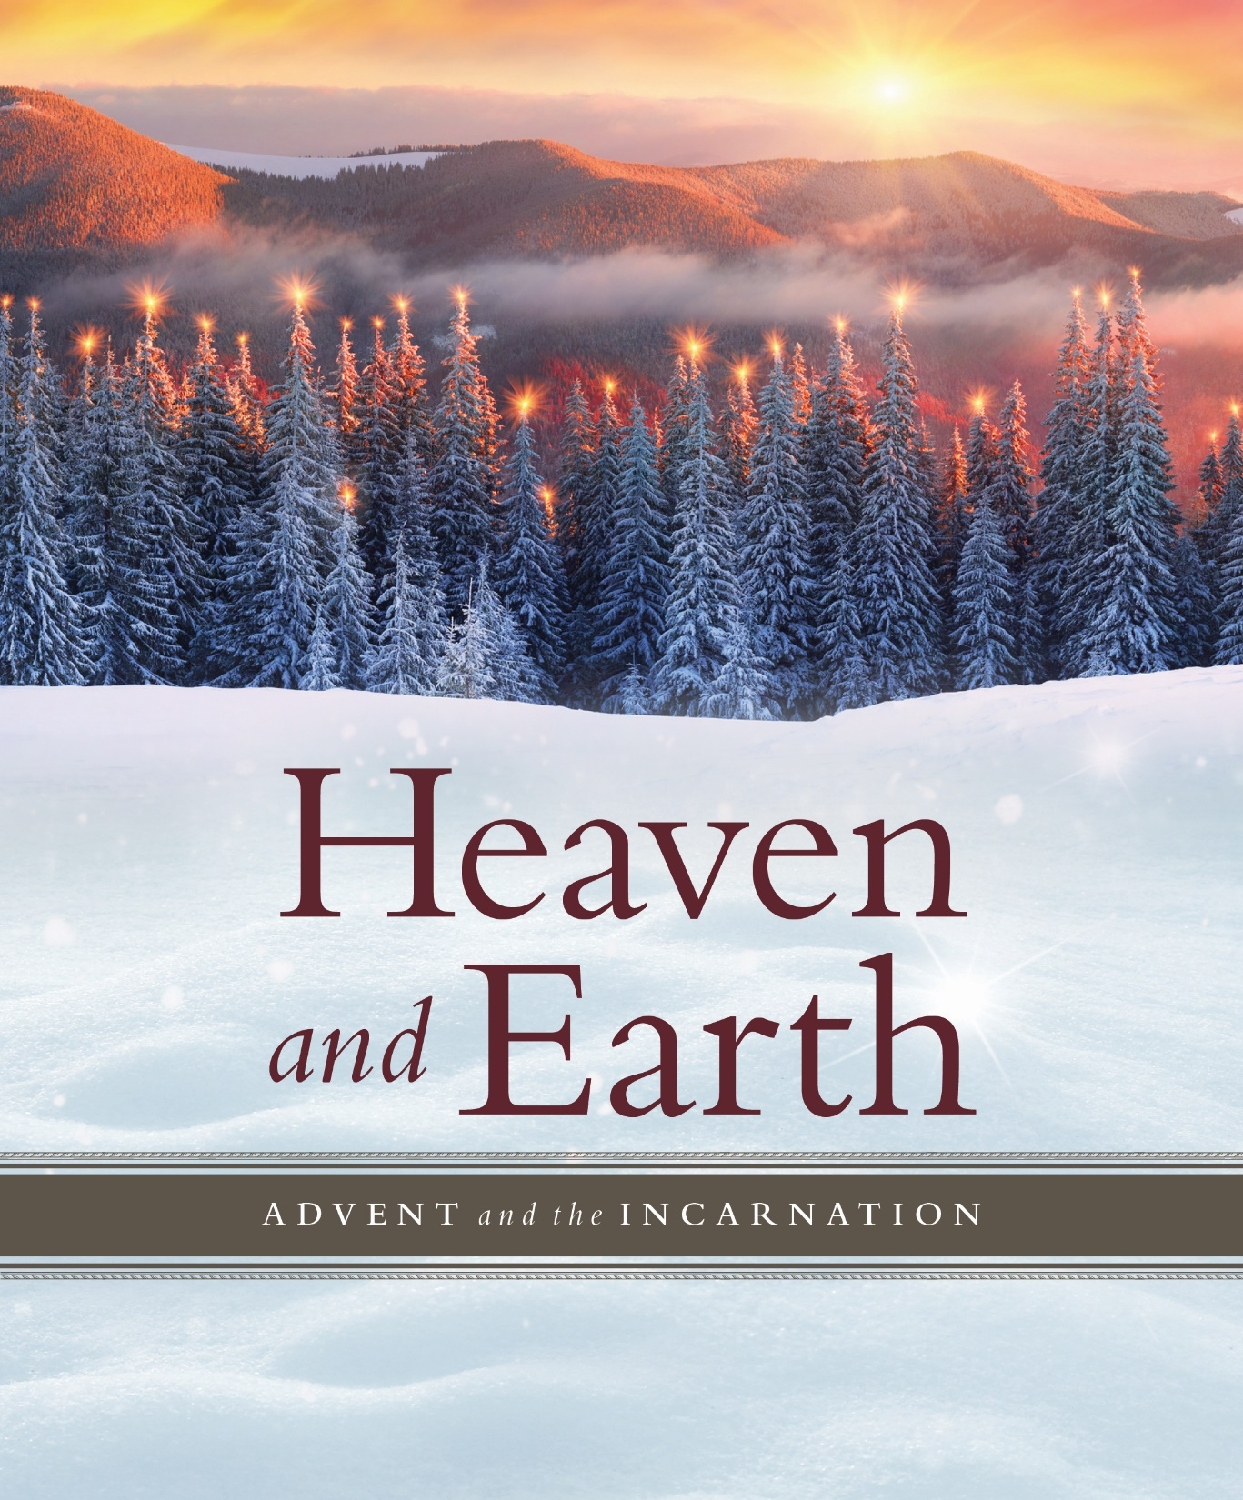
ANNOUNCEMENTS

PRAYER REQUESTS: Please pray for people in need in our church, community, nation,
and the World.
STEWARDSHIP CAMPAIGN: for the upgrade of the sound and video system at the
sanctuary and next year’s church budget.
CHURCH CONFERENCE: December 10th at 3:00 pm
WEDNESDAY CONNECTIONS: Meal served by Rod & Katrina McGillivray at 5:00 pm
WANTED: Team members for Dinner Church
DINNER CHURCH MINISTRY: December 13th at 5:00 pm.
ADVENT SEASON BIBLE STUDY: “Heaven and Earth” by Will Willimon with Video.
4 Sundays from Nov. 26 – December 17. 10:30 am. Facilitator: Pastor Inwha.
MORNING PRAYER: Church will be open for prayer 7-8:00 am.
SCRIP CARDS: Sunday, December 10 will be the last day to place an order for Scrip cards
for Christmas that are not on hand. To order, stop in the gathering area or call Marcia at
715-284-3346.
USHER/GREETERS: Leroy and Sarah Wiersma
FELLOWSHIP: Gil Homstad and Judy Hansen

UPCOMING MEETINGS
Mon Dec. 4 Trustees 5:00 pm
Tue Dec. 5 SPRC 5:30 pm
Sun Dec. 10 Church Conference 3:00 pm
Wed Dec. 13 Dinner Church Ministry 5:00 pm
Sun Dec. 24 Christmas Eve Candlelight Service 5:00 pm

BLACK RIVER FALLS
UNITED METHODIST CHURCH

UMC Mission Statement:
"To make disciples of Jesus Christ for the transformation of the world.”

PASTOR Rev. Inwha Shon

100 North Fourth Street, Black River Falls, WI. 54615
Phone: 715-284-4114 Office Hours: Monday-Thursday, 9 am-2 pm
Website: brfumc.org YouTube: brfumc
Facebook: Black River Falls United Methodist Church

